CIRCUIT ANALYSIS LAB_7
Name: Muhammad Uzair
Reg No: 2025-CE-112
Date: 3rdMay,2026

Experiment # 1:
Inverting OP-Amp:
Procedure for Inverting Amplifier:
1. Wire up the circuit as shown in the figure below on the breadboard.
2. Give the input to the inverting terminal of the op-amp and simultaneously display the input and
output on the oscilloscope.
3. Draw the input & output waveforms at the end of the lab.
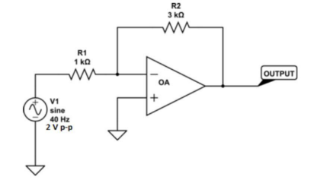

Experiment # 2:
Non-Inverting OP Amp:
Procedure for Non-Inverting Amplifier:
1. Wire up the circuit as shown in the figure below on the breadboard.
2. Give the input to the non-inverting terminal of the op-amp and simultaneously display the input and output on the oscilloscope.
3. Draw the input & output waveform at the end of the lab.
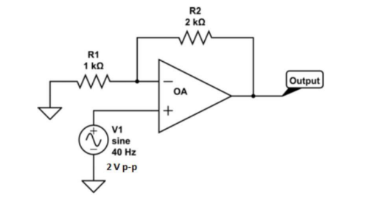

Graphs:
Input Signal:
Vertical Axis: 1 Box = 2V
Horizontal Axis: 1 Box = 1ms
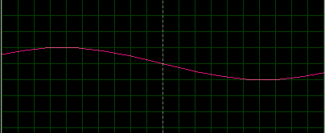
Amplified Inverted Output:
Vertical Axis: 1 Box = 2V
Horizontal Axis: 1 Box = 1ms
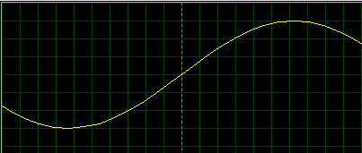
Amplified Non-Inverted Output:
Vertical Axis: 1 Box = 2V
Horizontal Axis: 1 Box = 1ms
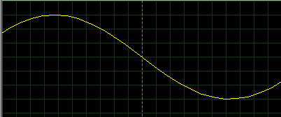
Post Lab Q/A:
- Define inverting amplifier.
An inverting amplifier is an operational amplifier (op-amp) configuration in which the input signal is applied to the inverting terminal (−). The output signal is 180° out of phase with the input, meaning it is inverted. A feedback resistor is connected from output to input to control gain. The non-inverting terminal (+) is usually grounded. It provides precise and stable amplification.
- Define Non-inverting amplifier.
A non-inverting amplifier is an op-amp configuration where the input signal is applied to the non-inverting terminal (+). The output signal is in phase with the input, meaning no inversion occurs. The inverting terminal (−) is connected through a feedback network. This configuration provides high input impedance. It is commonly used when signal polarity must be preserved.
- What are the applications of inverting amplifiers?
Inverting amplifiers are used in summing circuits (adding multiple signals). They are used in integrators and differentiators in analog computation. They are also used in signal processing and filtering circuits. Audio mixing and waveform shaping are common applications. Their precise gain control makes them useful in instrumentation.
- What are the applications of non-inverting amplifiers?
Non-inverting amplifiers are used in voltage followers (buffer circuits). They are widely used in sensor signal amplification. They are useful where high input impedance is required. Audio amplification systems also use this configuration. They help prevent signal loading in circuits.
- What is gain of an amplifier?
Gain of an amplifier is the ratio of output signal to input signal. It indicates how much the amplifier increases the signal strength. Gain can be voltage gain, current gain, or power gain. It is usually represented as a numerical value or in decibels (dB). Higher gain means stronger amplification.
- How do you calculate the gains for inverting and non-inverting amplifiers?
The gain of an inverting amplifier is given by: Gain = −Rf / Rin, where Rf is feedback resistance and Rin is input resistance. The negative sign shows phase inversion. For a non-inverting amplifier, gain is: Gain = 1 + (Rf / Rin). This gain is always positive, meaning no phase change. These formulas help in designing amplifier circuits accurately.

